**NAME:SHRIHARI BURKUL BATCH:DAC-A Assingment:3**

Loop based lab  
Q 1 wap to print number 1 to 100.

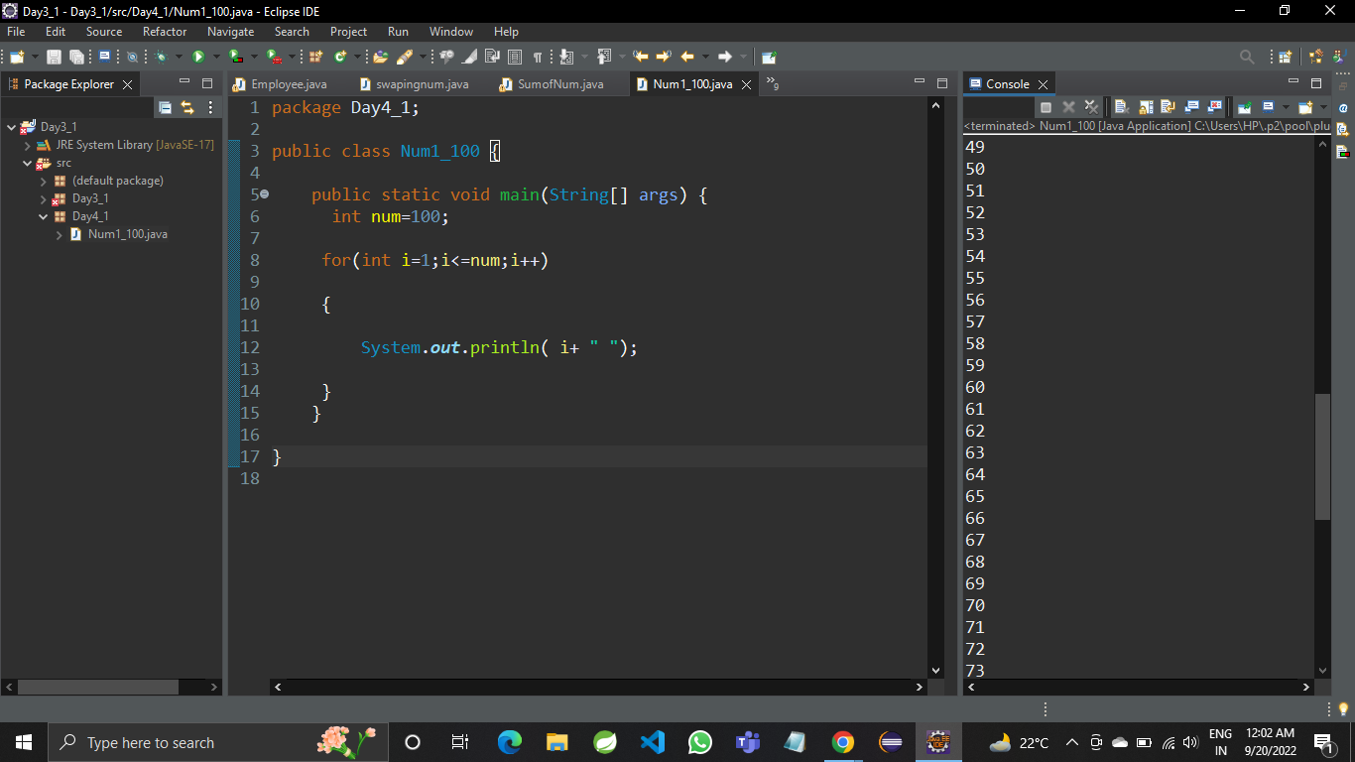

Q 2 wap to print even numbers between 1 to 20

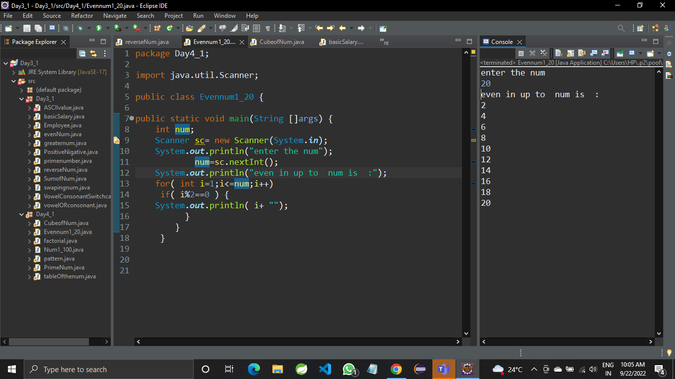

Q 3 wap to print cube of 1 to 5 number.

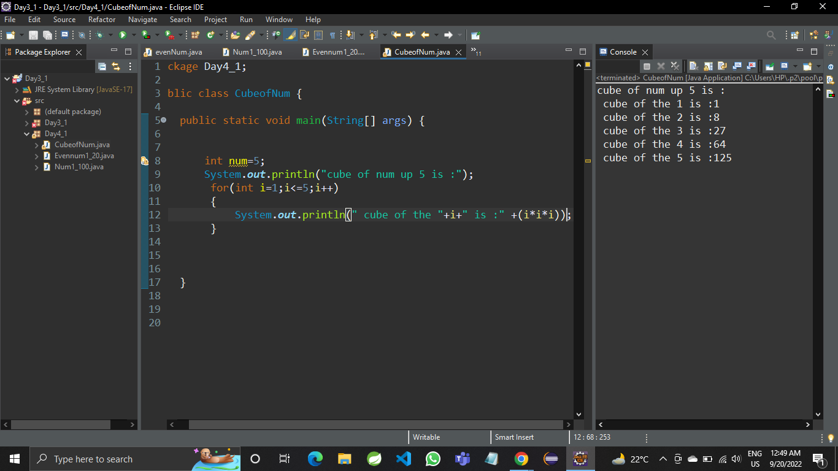

Q 4 wap to check if a number is prime or not .

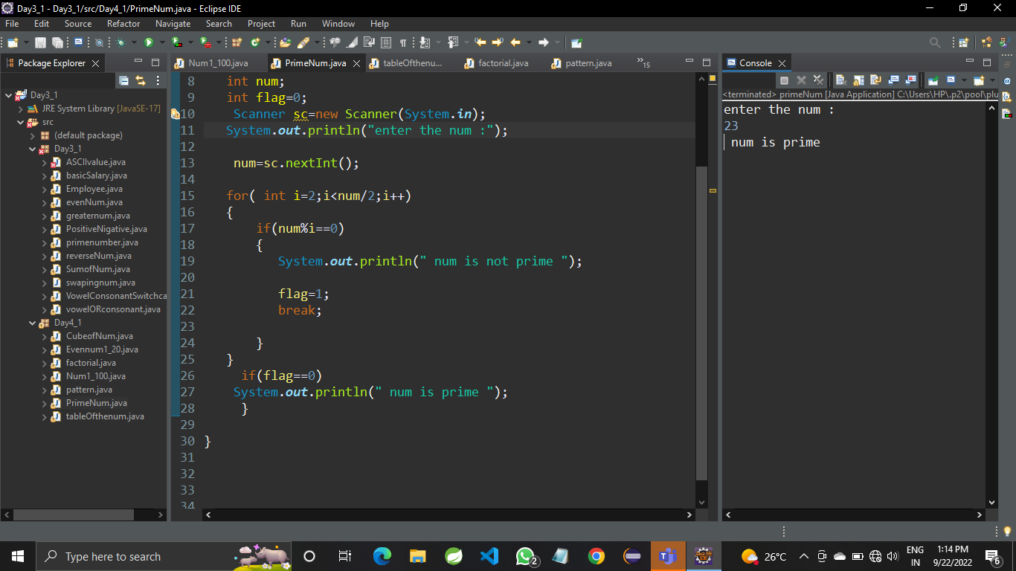

Q 5 wap to print fibonacci series using for loop i.e adding last two results  
ex  0 1 1 2 3 5 8 13 21 34

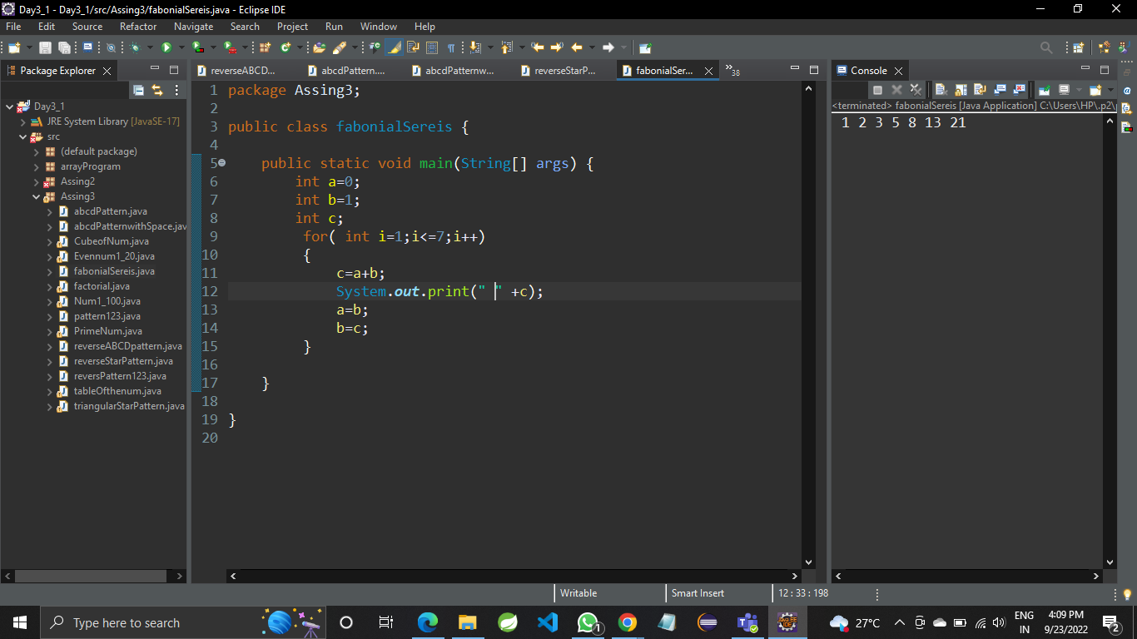  
  
Q 6 wap to print factorial of a number  
   5*4*3*2*1

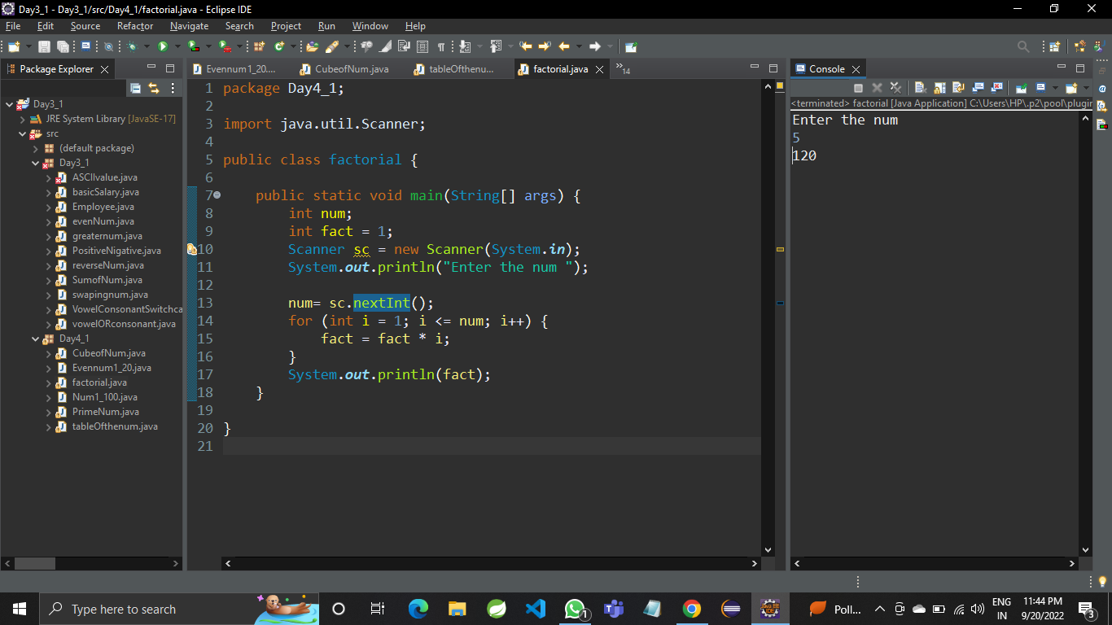

Q 7wap to ask a number from user and print table of that number

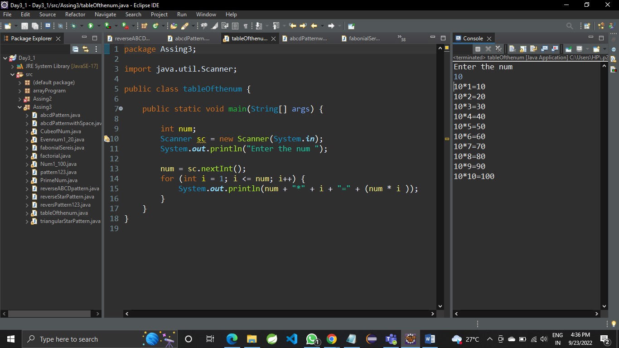

Q 8 wap to print prime numbers between 2 to 20

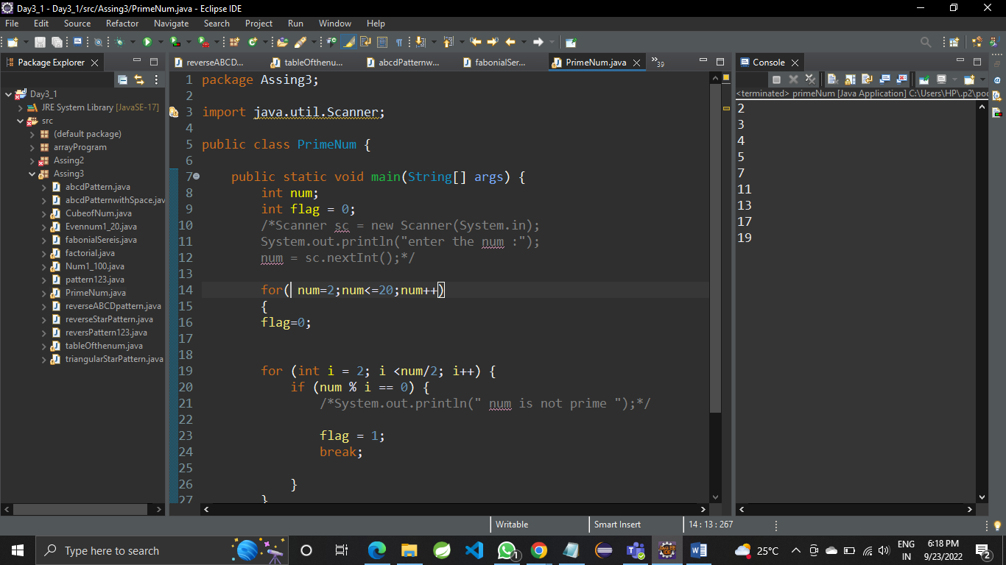

Q 9  print patterns like   
*  
**   
***  
****  
*****

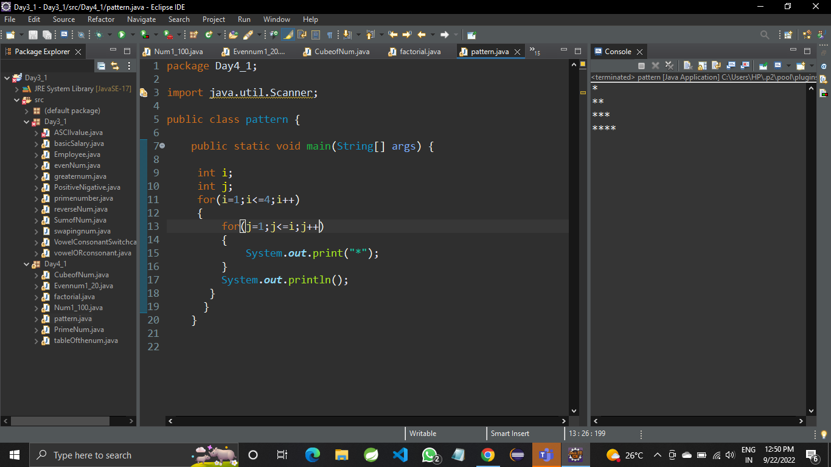

b) 1

1 2

1 2 3

1 2 3 4

1 2 3 4 5

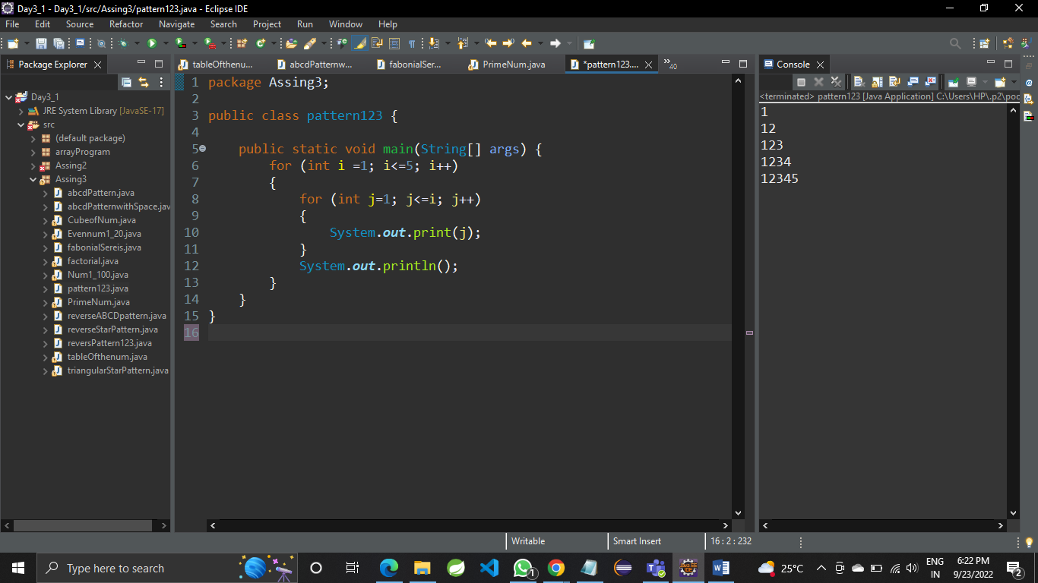

c) A B C D  
    A B C  
    A B   
    A

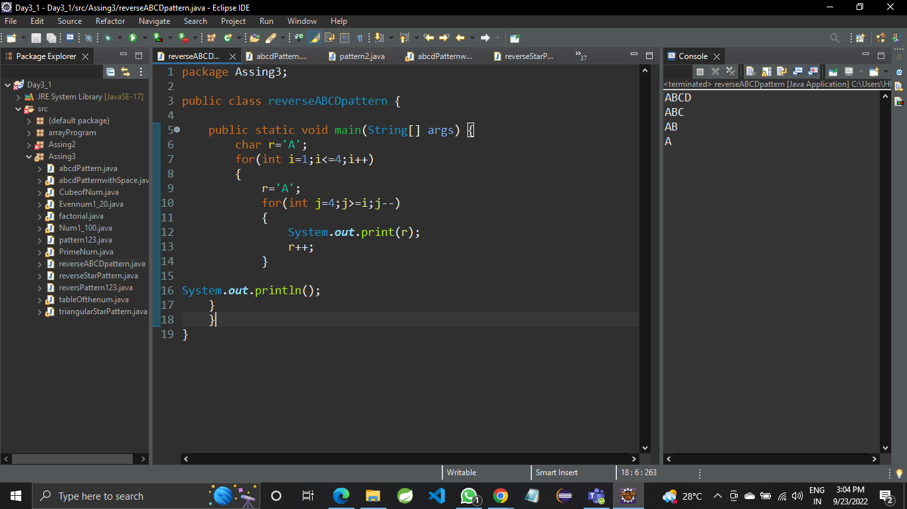

D   A B C D D C B A  
     A B C         C B A   
    A B                 B A

A A

                    